*Captain Cluster*

User Guide

August 3, 2017

Email:

[chris.fietkiewicz@case.edu](mailto:chris.fietkiewicz@case.edu)

Website:

[*https://drive.google.com/open?id=0B69p7kXgQZNQdndPX0Q3dkQyTWM*](https://drive.google.com/open?id=0B69p7kXgQZNQdndPX0Q3dkQyTWM)

Contents

Introduction 3

Installation 4

The Interface 5

Tutorial 8

# Introduction

Captain Cluster is an open-source, graphical utility for running jobs on the High Performance Computing Cluster (HPCC) at Case Western Reserve University. It was created in the lab of Dr. Chris Fietkiewicz and is not supported by the HPCC administration. It provides convenience for *simple* workflows where server interaction is limited to running a single script and where there are only a few file transfers to and from the user’s computer. The user must already have a functioning script (either .pbs or .sh). A typical workflow using Captain Cluster would be as follows:

1. Transfer files (including the main script) from the user’s computer to the server.
2. Execute the main script. This can be a job script (.pbs) or a shell script (.sh) that submits jobs.
3. Check whether jobs have finished.
4. Transfer files from the server to the user’s computer.

*Acknowledgements:* The primary software developers were Joonsue Lee, Jess Herringer, and Ethan Platt. Thanks to Hadrian Djohari and Sanjaya Gajurel at Case Western Reserve University for their assistance.

# Installation

*How to install*

The Captain Cluster application consists of only two required files, both of which are available from the from the Captain Cluster web folder. The required files are:

* CaptainCluster.py
* Settings.txt

Additionally, the application requires the following third party software:

* Python 2.7. Note that Python 3.X is not compatible with the wxPython libraries (see below).
* wxPython (<https://wxpython.org/>)
* Windows users will also need the free SSH utilities “plink” and “pscp” (available on the Captain Cluster web folder and also at <http://www.putty.org/>)

The Captain Cluster web folder contains complete installers for Windows and Mac, but they are very large (25 MB or larger). These install Python 2.7, so users who already have that may prefer to just install the additional items listed above.

*How to start the program*

The main program is called “CaptainCluster.py”. If Python was installed successfully, you should be able to double click on “CaptainCluster.py” to begin the program. You may also create a shortcut.

*License:* This software is distributed without warranty under the terms of the GNU Library General Public License as published by the Free Software Foundation.

# The Interface

The figure below shows the different parts of the user interface. See the following pages for descriptions.

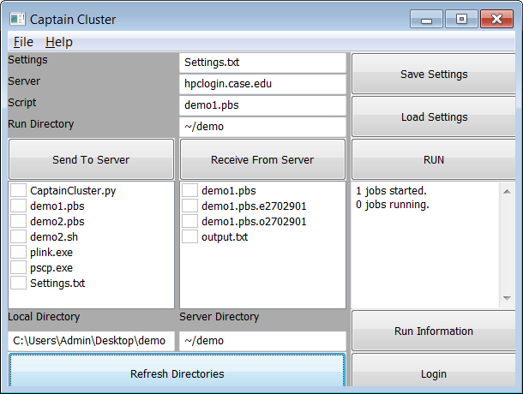

The following descriptions are for the figure above:

1. **Refresh Directories button:** Updates the file listings in 5 and 6. If not yet logged in, the user will be prompted to enter login information (see 2). Then the directories will refreshed.
2. **Login button:** Asks for the username and password for the user’s HPCC account. The user must log in once after starting the program before performing any actions on the server. The user can also click on 1 instead in order to avoid performing two steps. There is no need to log out. The username and password are not saved for future sessions and must be reentered every time the program is started.
3. **Local directory:** Path for the directory on the user’s computer. Contents of this directory will be displayed in 5 after clicking either 1 or 8.
4. **Server directory:** Path for the directory on the server. Contents of this directory will be displayed in 6 after clicking either 1 or 7.
5. **Local directory listing:** Contents of the directory in 3. Boxes can be marked for file transfers (see 7).
6. **Server directory listing:** Contents of the directory in 4. Boxes can be marked for file transfers (see 8).
7. **Send To Server button:** Sends files marked in 5 to the server directory in 4.
8. **Receive From Server button:** Retrieves files marked in 6 to the local directory in 3.
9. **Save Settings button:** Saves all settings (except user login information) in the file entered in 11. This includes the information entered in 3, 4, 11, 12, 13, and 14. The file will be saved in the local directory entered in 3.
10. **Load Settings button:** Loads the settings (except user login information) from the file entered in 11. Information is loaded for 3, 4, 11, 12, 13, and 14. The file must be in the local directory entered in 3.
11. **Settings file name:** Name of file to be used for saving program settings (see 9 and 10).
12. **Server URL:** Specifies the node to be used on the HPCC for controlling jobs.
13. **Script:** Name of a script that can be executed on the server using the Run button (see 15). The script must be located in the run directory entered in 14. It should be either a job script (.pbs) or a shell script (.sh). See 15 for more information on running the script.
14. **Run directory:** Directory on the server that contains the run script entered in 13. It does not need to be the same as the server directory entered in 4.
15. **Run button:** Runs the script entered in 13. If the filename ends in “.pbs”, a qsub command will be sent to the server using this file. If the filename ends in “.sh”, the file should be a valid shell script. Note that Captain Cluster does not automatically copy the file from the user’s local computer to the server.
16. **Run information display:** Displays the number of jobs that are in the user’s queue after clicking either 15 or 17. This is done by sending a “qstat” command to the server and counting the number of jobs that are in the queue. Note that it is ignorant of the actual status of the jobs (e.g. Q, R, C, etc.).
17. **Run information button:** Updates the information displayed in 16.
18. **Menu bar:** Options include loading a settings file, saving a settings file, quitting the program, and getting information about the program.

The tutorial below provides step-by-step instructions on how to use Captain Cluster.

# Tutorial

1. This tutorial requires you to have a directory in your home directory on the HPCC server named “demo”. Create the directory using your preferred method. Ask for help if you do not know how to do this.
2. Find the file called “CaptainCluster.py” on your local computer. Double click on “CaptainCluster.py” to begin the application. Later, you may wish to create a shortcut for convenience. If Python was installed successfully, you should see the following screen appear.

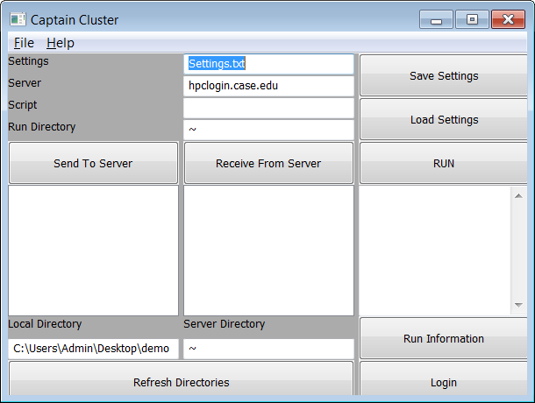

1. Enter “/demo” for the *Server Directory* as shown below. NOTE: You should have already created this directory in step #1.

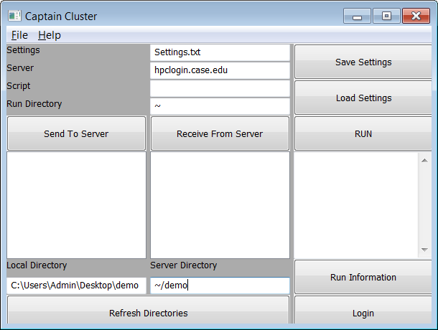

1. Click the “Refresh Directories” button to begin a connection to the server. After first starting the application, the application will ask for your username and password (see the Figure on the left). This is only required once. Enter your login information in the appropriate boxes. After logging in, you should see the files listed for your *Local Directory* and the *Server Directory* (see the Figure on the right). Note that you should not have any files in the *Server Directory* yet. You will transfer a file in the next step.

|  |  |
| --- | --- |
|  |  |

1. Place a check in the box for “demo1.pbs” as shown below.

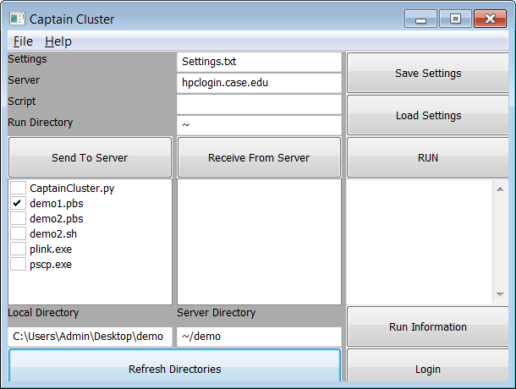

1. Click on the “Send To Server” button. You should see a window appear that indicates the file transfer as shown below on the left. If successful, you should see the file “demo1.pbs” listed in the *Server Directory* as shown below on the right.

|  |  |
| --- | --- |
|  |  |

1. Type “demo1.pbs” in the Script box, and type “/demo” in the Run Directory box as shown below.

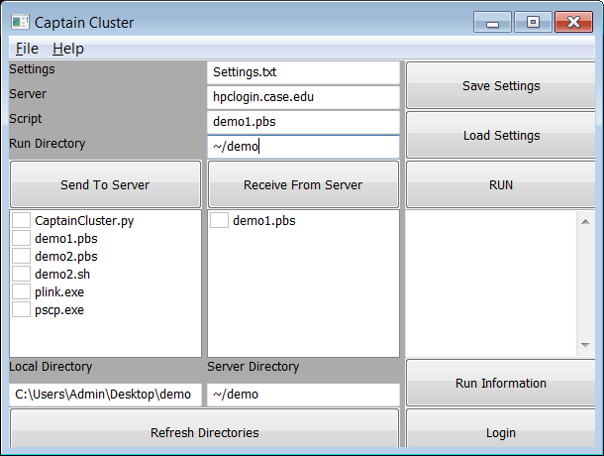

1. Click the “Save Settings” button and then the “Refresh Directories” button. You should notice a new file named “Settings.txt”.
2. Click the “Run” button to execute the script entered in the *Script* box. Then click the “Run Information” button. You should see the message “1 jobs started” in the *Run Information* area, indicating that your job was started, as shown below.

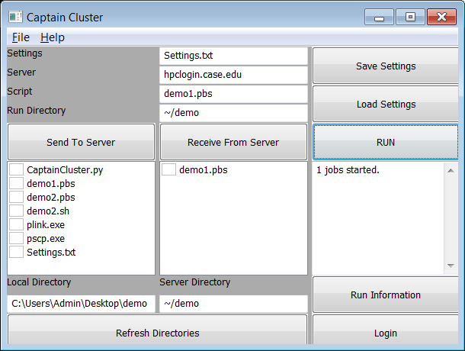

1. Continue clicking on the “Run Information” button until there are “0 jobs running”, as shown below on the left. Then click the “Refresh Directories” button. You should see three new files listed in the *Server Directory* as shown below on the right. The two new files with names beginning with “demo1” are the error and screen output files that are generated for reporting. The job output file is named “output.txt”.

|  |  |
| --- | --- |
|  |  |

1. Check the box for “output.txt” and click the “Receive From Server” button as show below on the left. You should see in the Python window that the file is being transferred, as shown below on the right.

|  |  |
| --- | --- |
|  |  |

1. You should now see the file “output.txt” in the *Local Directory* list as shown below.

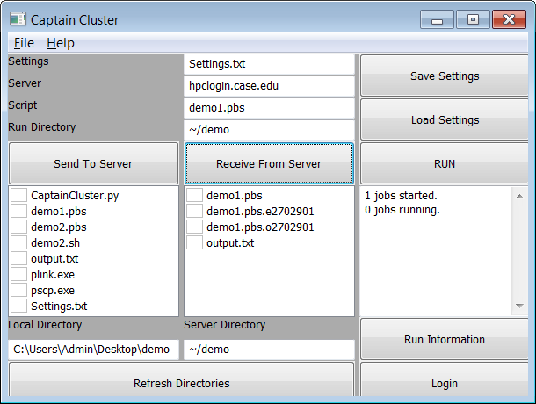

1. On your own computer, open the file “output.txt”. You should see the following in the file:

“Hello! This is a demonstration script for Captain Cluster.”